Game Hardware 3

CA Project

Submitted by Liam Ross (A00282639)

**Introduction:**

This aim of this project was to use the OpenCV python package along with trained algorithms to detect specific objects in images and videos.

For my project, the detection methods I chose were, face and eye detection, face and smile detection, number plate detection and car detection. I chose these detection methods as I found them to be the most interesting and I felt that I could generate a lot of samples. I sourced various images and videos online to use for my project, which can all be found in the Code/images and Code/videos folders. I have also included links to the original sources for all these images and videos below.

The python package that I used in this project was OpenCV. OpenCV is an open source, cross platform, library of programming functions aimed at real time computer vision.

All the python scripts I created for this project all followed a similar manner. Here is an example of the script I used for Face and Eye Detection.

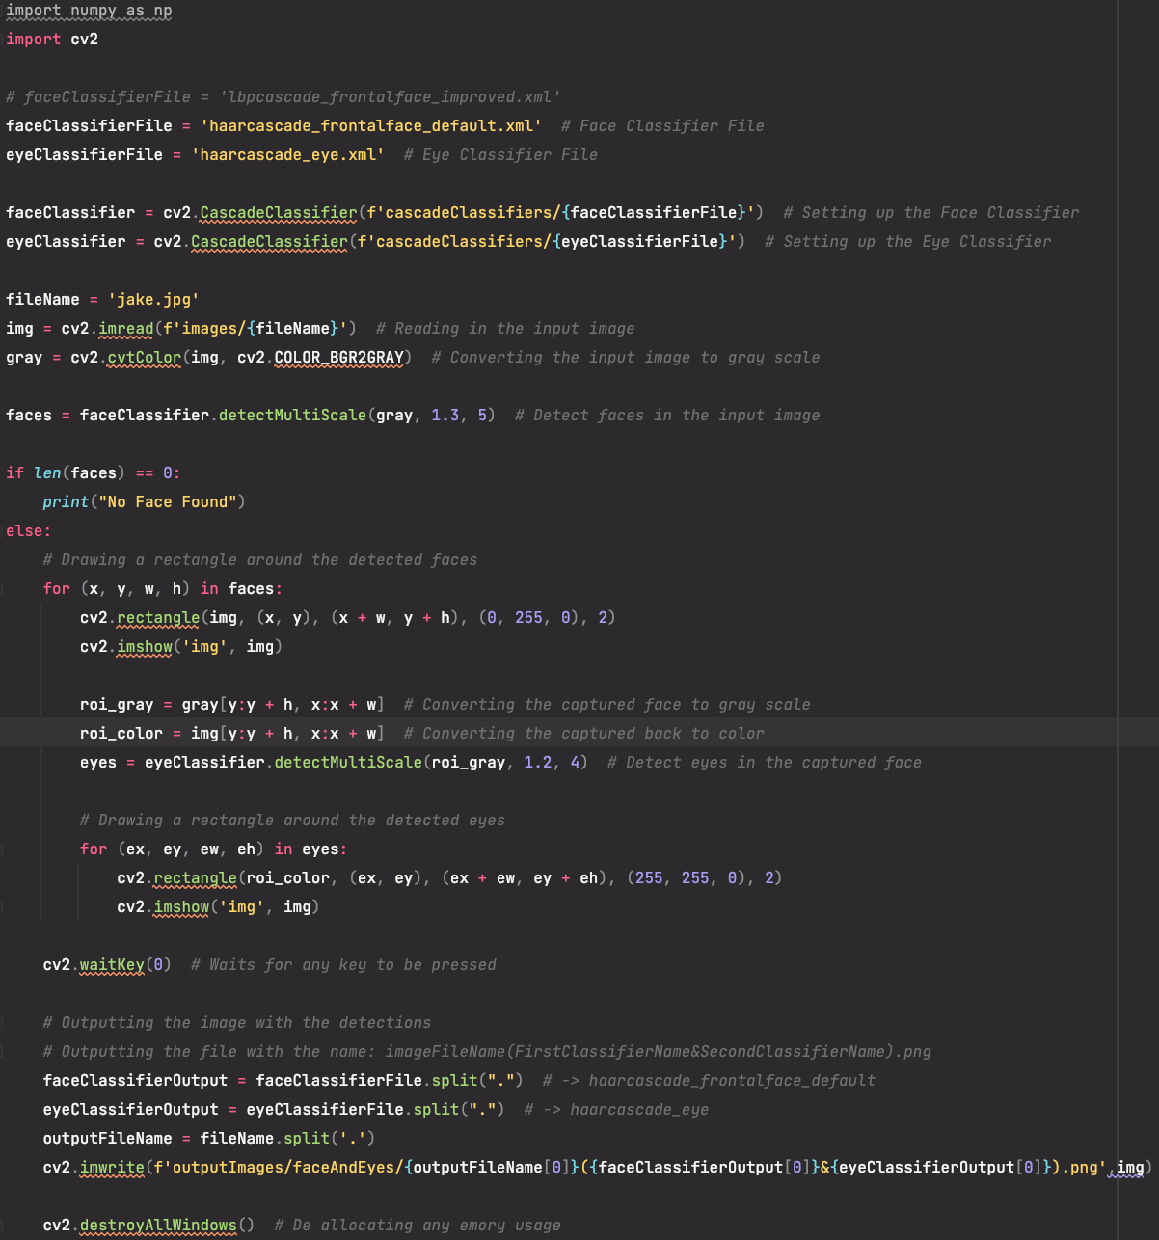

Figure 1: Python script used for detecting faces and eyes in PyCharm.

**Tech Stack:**

OS:

* macOS Monterey – Version 12.4

Python:

* Version: 3.10

Packages:

* OpenCV – Version: 4.6.0.66
* Numpy – Version: 1.23.5

Environment

* PyCharm IDE – Version 2022.2.4

Classifiers:

* haarcascade_russian_plate_number.xml
* haarcascade_car.xml
* haarcascade_frontalface_default.xml
* lbpcascade_frontalface_improved.xml
* haarcasade_smile.xml
* haarcascade_eye.xml

Python Source Files:

* CarsImage.py
* CarsImageImproved.py
* CarsVideo.py
* FaceAndEye.py
* Smile.py
* NumberPlate.py
* NumberPlateVideo.py

**Detections:**

**Face and Eye Detection**

Classifiers Used: haarcascade_frontalface_default.xml & haarcascade_eye.xml

Python Script Used: FaceAndEye.py

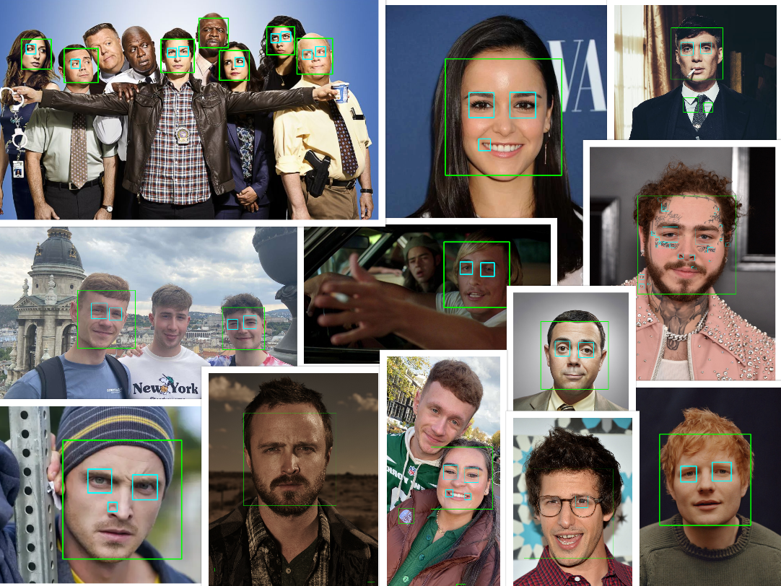

Figure 2: Results from Face and Eye Detection Sample 1.

Classifiers Used: lbpcascade_frontalface_improved.xml & haarcascade_eye.xml

Python Script Used: FaceAndEye.py

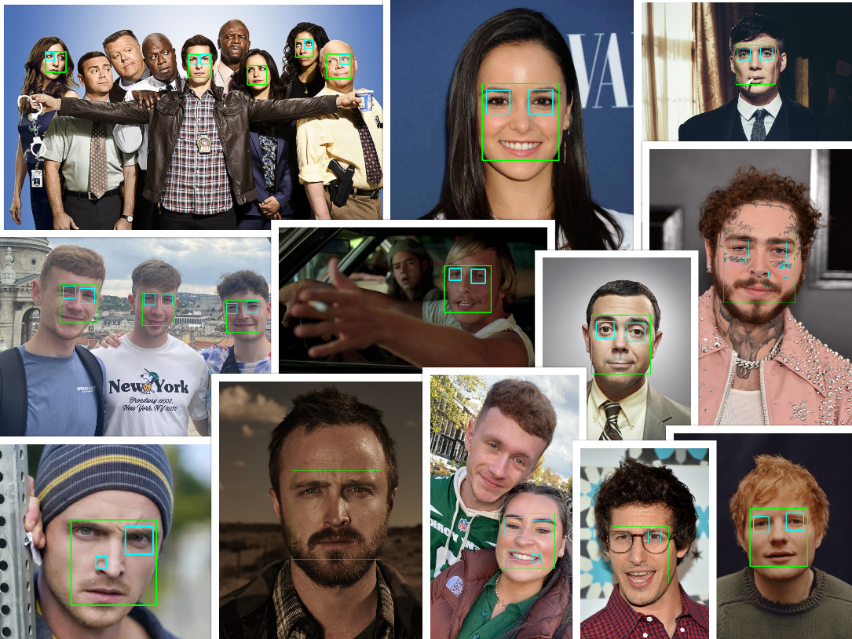

Figure 3: Results from Face and Eye Detection Sample 2.

For face and eye detection, I ran two detection samples with two different face classifiers on each of the sample images that I gathered. In the first sample, I used the haarcascade_frontalface_default classifier and in the second sample I used the lbpcascade_frontalface_improved classifier. I used the haarcascade_eye classifier on both samples. The green boxes indicate a facial detection, and the cyan boxes indicate an eye detection.

My goal was to see which classifier was more accurate for facial detection and what effect that had on detecting the eyes. From Figure 2 and Figure 3 above, you can see that both classifiers gave very similar results in most cases. However, I do think that the lbpcascade_frontalface_improved classifier was more accurate in detecting faces and it gave off fewer invalid detections. As you can see from Figure 4 below, the image on the left contains two invalid facial detections around the upper chest area, indicated by the arrows, whereas the image on the right does not.

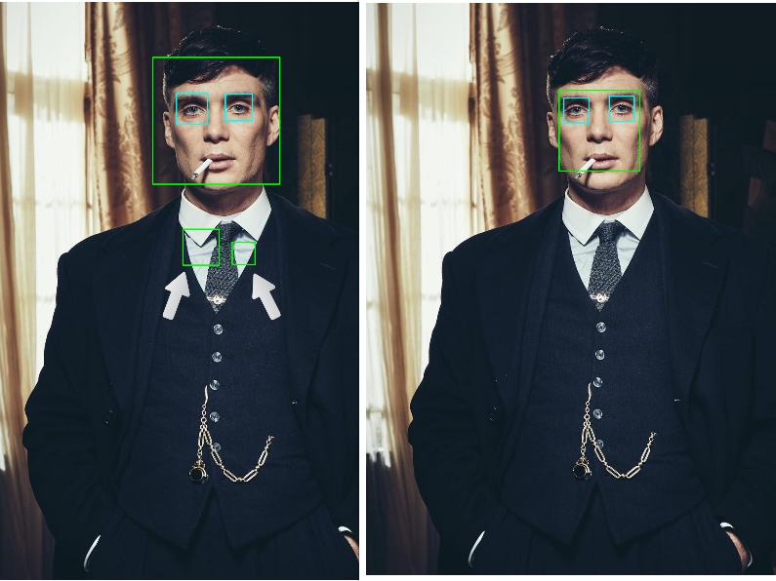

Figure 4: Left: haarcascade_frontalface_default, Right: lbpcascade_frontalface_improved

I also believe that, in most cases, because the lbpcascade_frontalface_improved classifier gave a more accurate facial detection, it led to a more accurate eye detection, as well as fewer invalid detections. As you can see from Figure 5 below, the face of the man in the middle on the top image was not detected at all, whereas in the bottom image, his face was detected which then led to his eyes also being detected. You can also see from the green boxes, indicating a facial detection, in both Figure 4 and Figure 5 for the lbpcascade_frontalface_improved classifier, that they are much smaller than the haarcascade_frontalface_default classifier, indicating a more accurate detection of the face.

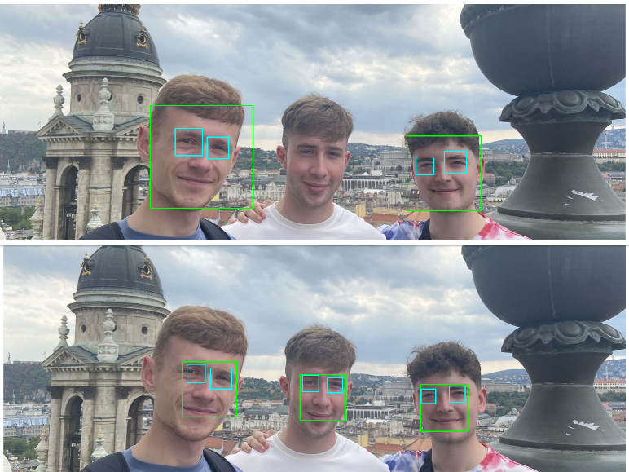

Figure 5: Top: haarcascade_frontalface_default, Bottom: lbpcascade_frontalface_improved

I also ran another two smaller detection samples, specifically on images of people that were wearing glasses. I used both face classifiers along with the eye classifier for these samples as firstly, I wanted to see if the eye classifier was able to detect the eyes underneath the glasses and if so, would the face classifier used have any effect. The results can be seen in Figure 6 and Figure 7 below.

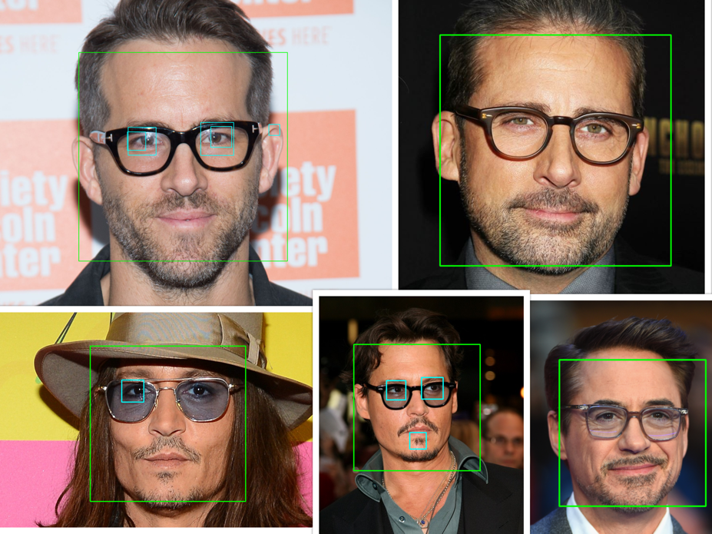

Figure 6: Results from the using haarcascade_frontalface_default classifier.

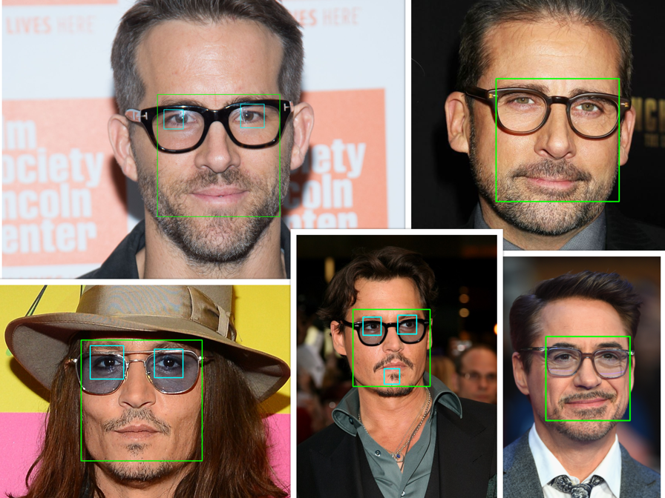

Figure 7: Results from using the lbpcascade_frontalface_improved classifier.

As you can see from the results, both samples gave very similar results. Eyes were captured under the glasses in only three of the images and this was consistent for both facial classifiers used.

There were a couple minor exceptions though. As you can see from the bottom left image in Figure 6, only the man’s left eye detected, whereas in Figure 7, both of his eyes were detected. I believe this was because of the face classifier that was used. The lbpcascade_frontalface_improved classifier captured the face more accurately which led to both eyes being detected. The eyes of the man in the image in the top left corner in both Figure 6 and Figure 7 were detected. However, as you can see in Figure 6, the image contains two cyan boxes around the eyes, whereas in Figure 7, there is a single box around each eye, indicating a more accurate detection.

**Face and Smile Detection**

Classifiers Used: lbpcascade_frontalface_improved.xml & haarcascade_smile.xml

Python Script Used: Smile.py

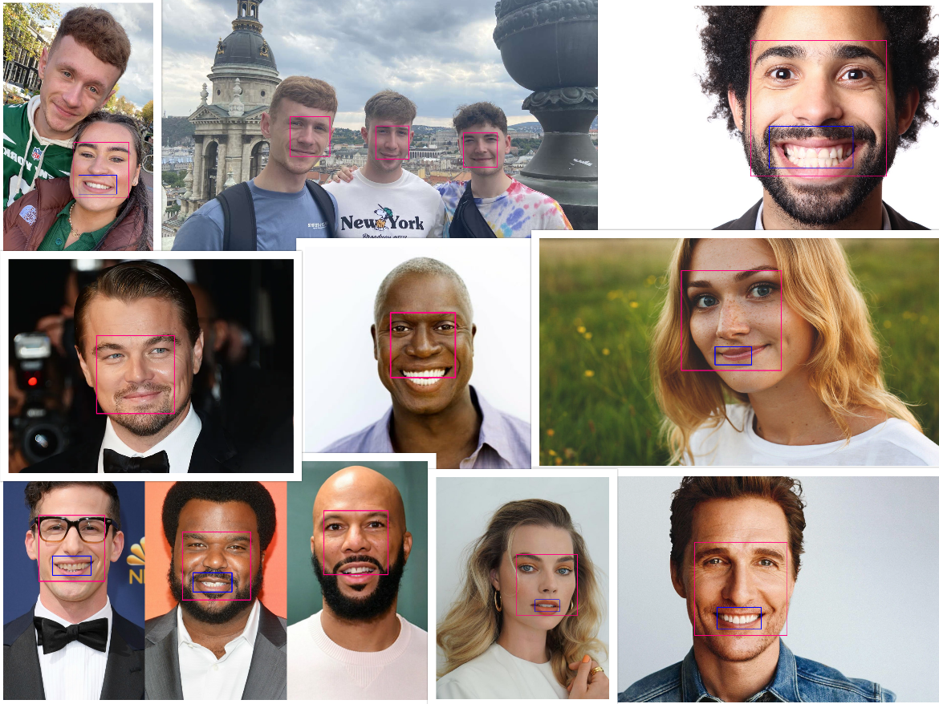

Figure 8: Results from Face and Smile Detection.

For face and smile detection, the classifiers I used were lbpcascade_frontalface_improved and haarcascade_smile. I decided to use lbpcascade_frontalface_improved for the facial detections over the haarcascade_frontalface_default as I thought it was the more accurate classifier after completing my face and eye detection samples. The results can be seen in Figure 8, where the pink box indicates a facial detection, and the blue box indicates a smile detection.

After I ran the face and smile detection samples, I found the haarcascade_smile classifier to be quite accurate. Almost all the smiles of the people in the sample images were detected. However, there were some exceptions as in some images, the face was detected but the smile was not, even though the person was clearly smiling with their teeth. As you can see from Figure 9 below, both men are smiling with their teeth, but their smile was not detected.

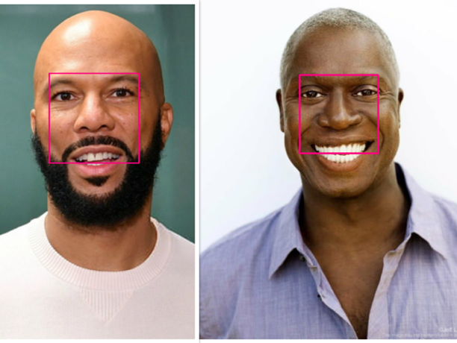

Figure 9: Smiles not detected due to facial detection.

My initial thought was the images were just bad and the classifier could not detect the smiles, however after inspecting it further, I noticed that the pink boxes around the face were very small and were cutting off the smile. I realized then that because the face was not properly captured, this meant that the smile was not detected at all.

After realizing this, I decided to run another test specifically on the images where smiles were not detected with the haarcascade_frontalface_default classifier to see if I would get different results. The results from the first two images are shown in Figure 10 below and it clearly shows that the smiles were detected. As you can see the pink boxes are bigger and captured more of the face which in turn allowed for the smiles to be detected.

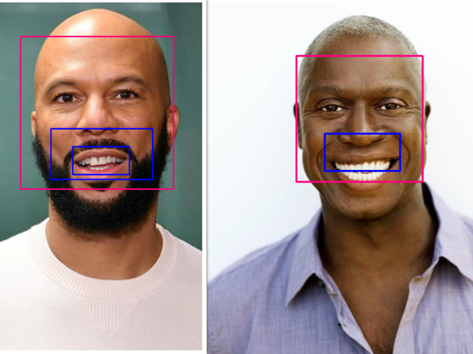

Figure 10: Smiles detected using the haarcascade_frontalface_default classifier

However, the haarcascade_frontalface_default classifier along with the haarcascade_smile did not always give accurate results. The results from the second two images are shown in Figure 11 below. As you can see from the image on the left, only one of the two smiles was detected. I am not including the man in the middles smile in this sample as I have already shown in Figure 5 that the haarcascade_frontalface_default classifier could not detect his face. From the image on the right, you can see that his smile was, in fact, detected, however the image also contains two invalid detections.

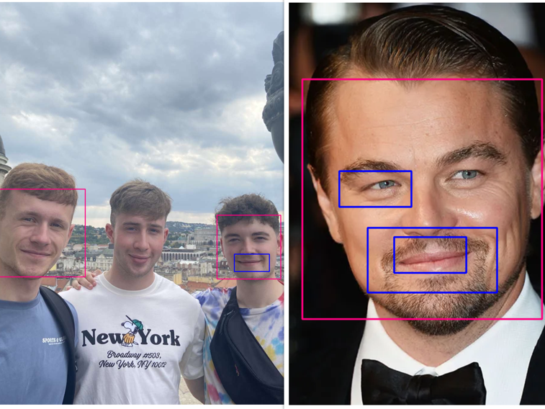

Figure 11: Inaccurate smile detections using the haarcascade_frontalface_default classifier.

**Number Plate Detection**

Classifiers Used: haarcascade_russian_plate_number.xml

Python Scripts Used: NumberPlate.py, NumberPlateVideo.py

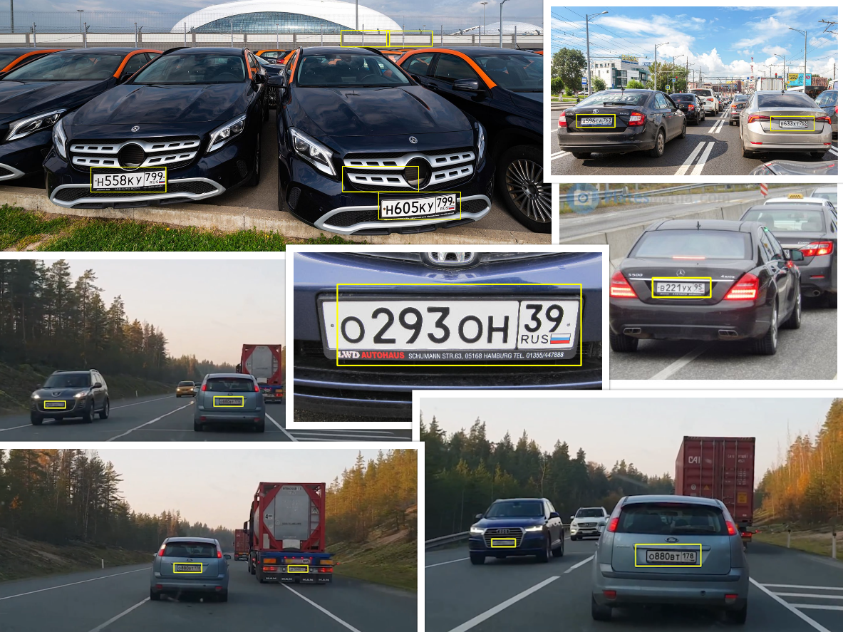

Figure 12: Results from Detection on Russian Number Plates only.

Classifiers Used: haarcascade_russian_plate_number.xml

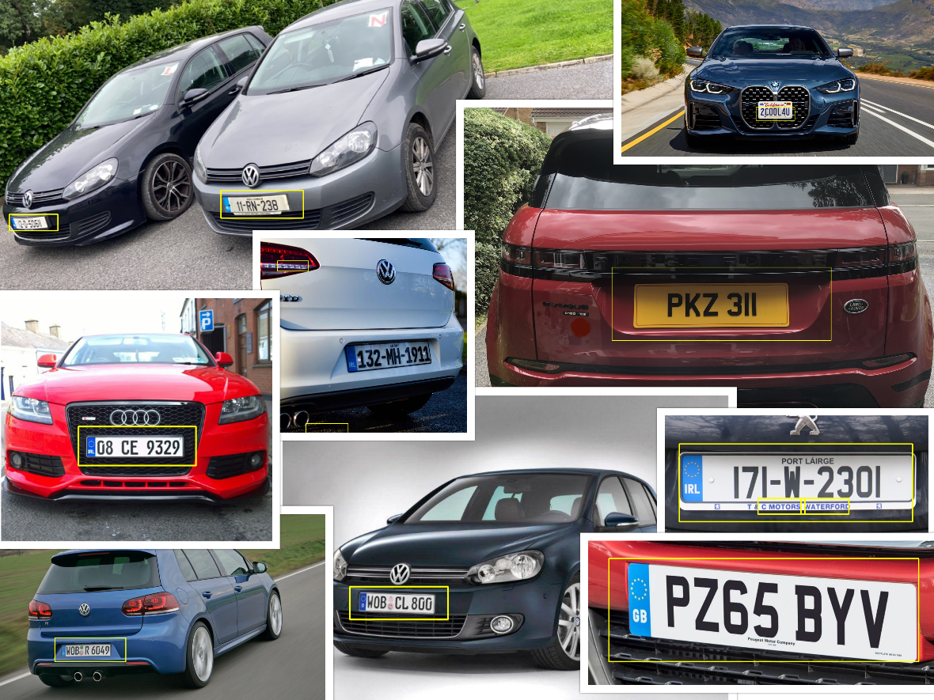

Figure 13: Results from Detection on various types of Number Plates.

For number plate detection I used the haarcascade_russian_plate_number classifier. I ran two sample detections with this classifier. In the first one, I used only Russian number plates and then in the second one, I used a variety of number plates, including Irish, English, and German. The results can be seen in Figure 12 and Figure 13 above, where the yellow boxes indicate a number plate detection.

I felt the need to run these two samples as I was originally under the impression that the classifier would only be able to detect Russian number plates as the name of the classifier suggested. Upon running the second sample, I found myself to be wrong as the classifier worked for almost all kinds of number plates. Even though the classifier worked all number plates, I did find that Russian plates were more easily detected. As you can see from all the images in Figure 12, and closer in Figure 14, the Russian plates were very accurately detected, even from a distance, in all the sample images and the sample video as the yellow boxes were almost perfectly around the number plates.

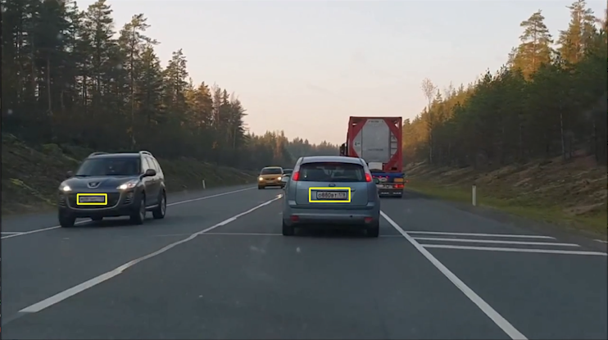

Figure 14: Accurate Russian Number Plate Detection.

As I have already stated, in the second sample, as shown in Figure 13, I ran tests on Irish, English, and German number plates and I was able to get detections on these using the same classifier. Even though, I was able to get detections, I don’t believe the classifier was as accurate at detecting these types of plates. As you can see from the images in Figure 13, the yellow boxes around the number plates are much bigger as opposed to the ones in Figure 12. Figure 15 below shows a closer view of a German number plate. As you can see the number plate is being detected, however it does not appear to be as accurate is not perfectly around the number plate.

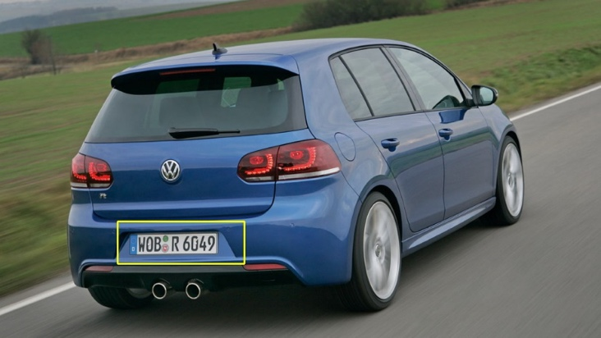

Figure 15: German Number Plate Detection.

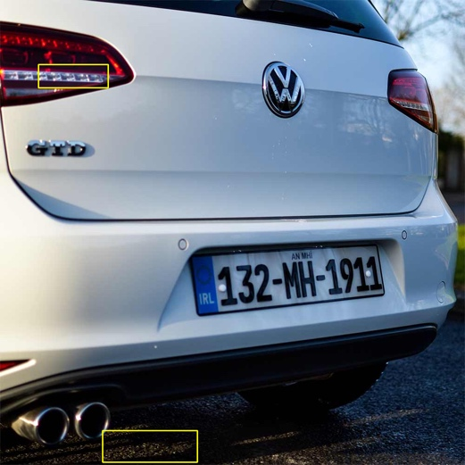

Figure 16: Irish number plate not detected.

The classifier did not always work with every number plate. As you can see from Figure 16 above, the classifier could not detect the Irish number plate, and has two invalid detections indicated by the two yellow boxes.

**Car Detection**

Classifiers Used: haarcascade_car.xml

Python Scripts Used: CarsImage.py, CarsVideo.py

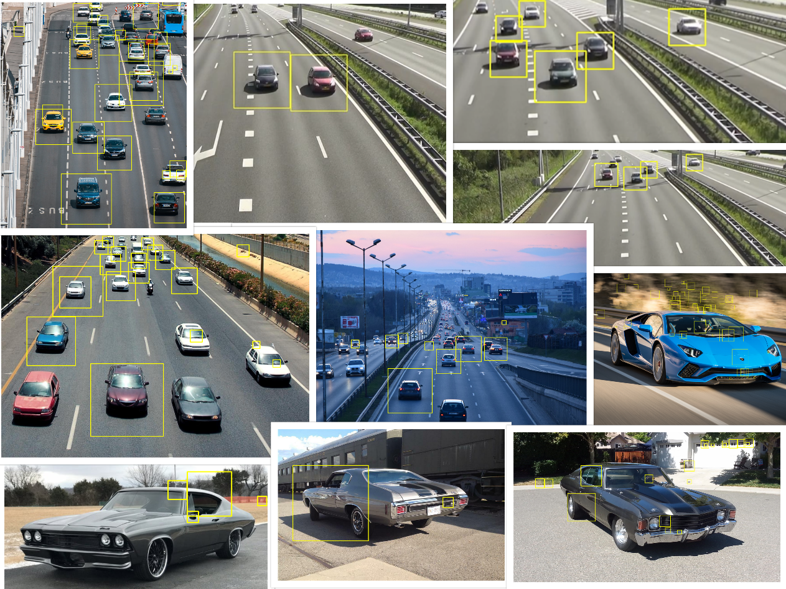

Figure 17: Results from Car Detection.

For car detection I used the haarcascade_car classifier. The results can be seen in Figure 17, where the yellow boxes indicate a car detection.

I found that the classifier was unable to detect cars up close and only able to detect those that were at a distance. I am not exactly sure why this is the case; however, my best guess is that this was the way that the classifier was trained. As you can see from Figure 18, the cars in these images were not detected properly at all and contained many invalid detections. This was something I that tried to fix by playing around with different values for the parameters in the detectMultiScale method however I could get a result I was satisfied with.

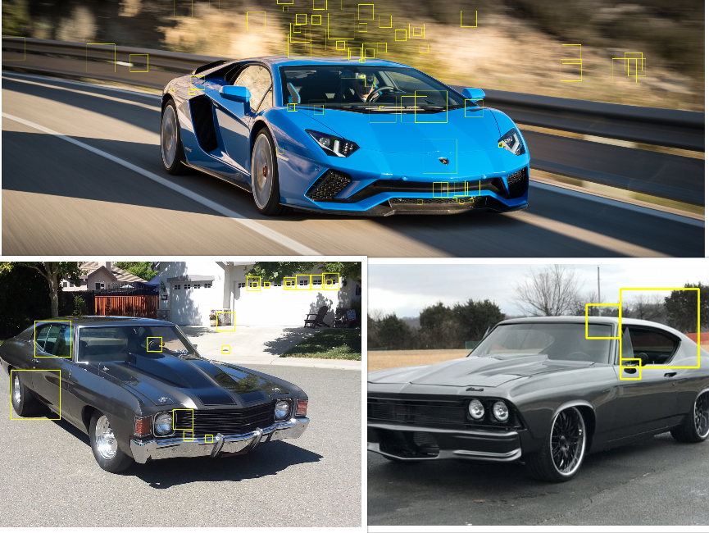

Figure 18: Invalid Car detections.

The sample images I used of cars that were at a distance worked quite well. As you can see from the images at the top of Figure 17 and more closely in Figure 19, the classifier was able to detect cars that were facing both towards and away from the camera. However, the classifier was not always perfect, as not all cars were detected and the images do contain several invalid detections

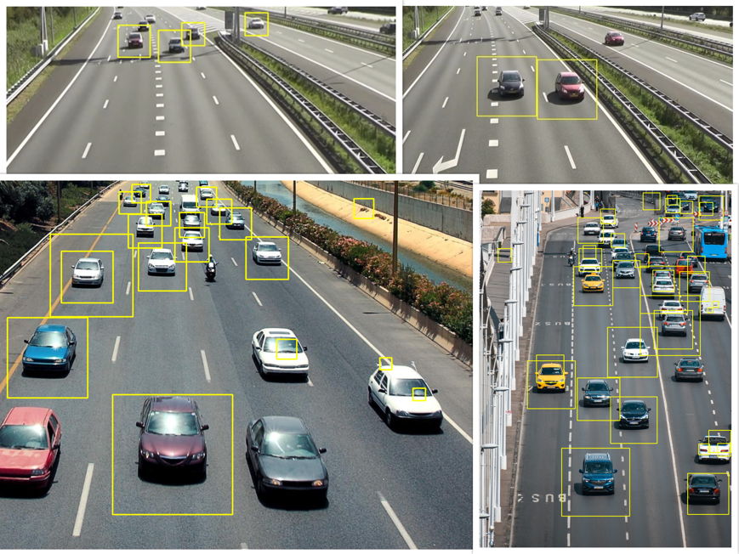

Figure 19: Cars detected from a distance.

**Conclusion:**

After running all my samples on all my detection methods, I was satisfied with my results. I feel that I was able to get accurate detections across all the methods I chose. The classifiers that I used were very accurate at detecting what they were trained to detect. I firmly believe that all the classifiers work best with high resolution images, as I had to discard many of the sample images that I gathered due to them being unusable with the classifiers.

I also feel that I could have expanded on the python scripts a bit more to possibly get more accurate detections. Upon researching, after I had completed all my detection samples, I found that blurring and dilating an image after converting it to gray scale might have helped with more accurate detections particularly with detecting cars. The use of a different detection algorithms, such as the YOLO (You Only Live Once) object detection algorithm, which is a very fast and highly accurate algorithm, might also have led me to more accurate detections.

I was intrigued to see if the method of blurring and dilating the image after converting it to gray scale would improve my detections, so I decided to run a quick sample test on some of my car sample images. The results can be seen in Figure 20 below. I was very satisfied with the results, as you can see, a more cars were more accurately detected as opposed to the results without using this method in Figure 17 and Figure 19.

Classifier Used: haarcascade_car.xml

Python Script Used: CarsImageImproved.py

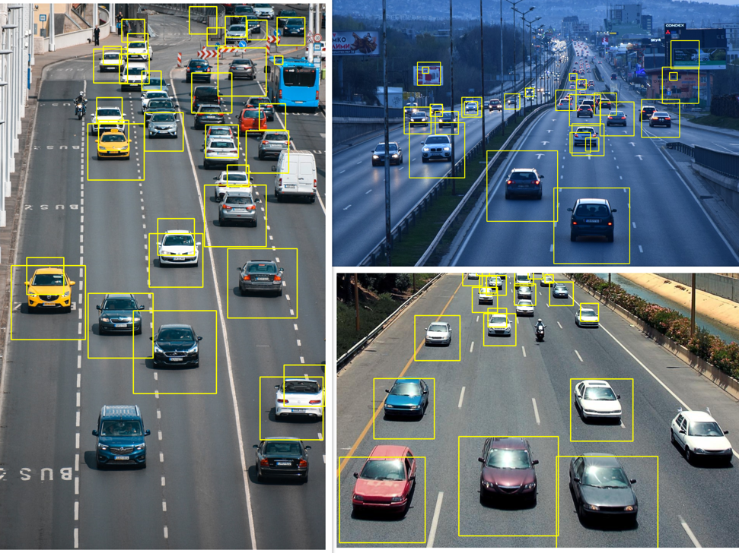

Figure 20: Results from Improved Car Detection test.

To implement this new method, I first converted the image to grayscale, shown in Figure 21. This was the technique I used in all of my detection samples. I then applied Gaussian blur to the image, as shown in Figure 22. By applying Gaussian blur to the image, the details of the image were removed as well as the noise being reduced and the image smoothed out. Lastly, I dilated the image, as shown in Figure 23. Dilation is a morphological technique that adds pixels to the boundaries of objects in an image. I then passed the dilated image to the classifier to get the output image.

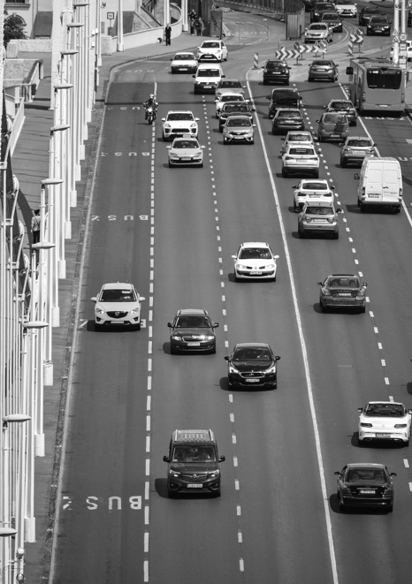

Figure 21: cars1.jpeg after converting to grayscale.

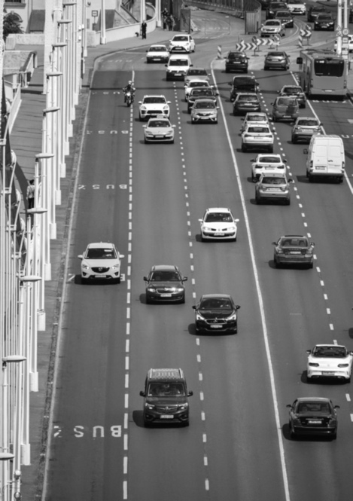

Figure 22: cars1.jpeg after applying Gaussian blur on top of grayscale.

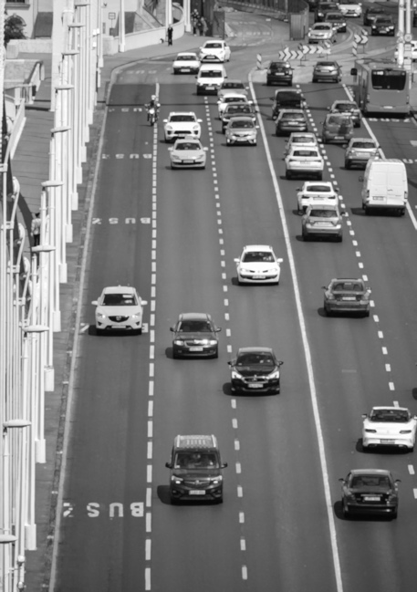

Figure 23: cars1.jpeg after dilation on top of Gaussian blur and grayscale

I feel that I have a lot learned with regards to OpenCV, and I feel I have a decent understanding of how object detection and how the algorithms behind them work. I am highly interested in expanding my knowledge in this area. I plan on trying to expand on the python scripts I have written for this project to try and get more accurate and sophisticated detections. I also plan on trying the OpenCV C++ library as well, as C++ is something that I already have an interest in and feel comfortable in.

**References:**

**Images:**

cars.jpeg: <https://tinyurl.com/mu66rndw>

cars1.jpeg: <https://tinyurl.com/5n7ksa3v>

chevelle70.jpg: <https://tinyurl.com/s34jywuc>

chevelle68.jpg: <https://tinyurl.com/yn6v8uwz>

chevelle71.jpg: <https://tinyurl.com/nh533zmx>

golf1.jpg: <https://tinyurl.com/v586avpn>

golf2.jpg: <https://tinyurl.com/2p8wmy5v>

b991.jpg: <https://tinyurl.com/49rhv3rk>

post.jpg: <https://tinyurl.com/mwcaunm4>

tommy.jpg: <https://tinyurl.com/mr3dft8p>

dazed3.jpg: <https://tinyurl.com/53w3xkdh>

smileWoman.jpg: <https://tinyurl.com/2wn2my9c>

smileMan.jpg: <https://tinyurl.com/bddfc6d4>

leo.png: <https://tinyurl.com/bddp26cr>

matthew.png: <https://tinyurl.com/3y46da5s>

boyle.jpg: <https://tinyurl.com/2627nktj>

amy.png: <https://tinyurl.com/3c3snykn>

jesse1.png: <https://tinyurl.com/yck9jswt>

jake.jpg: <https://tinyurl.com/492w6jv8>

steve.jpeg: <https://tinyurl.com/yc7e3dp8>

tony.png: <https://tinyurl.com/3834ht4k>

ryan.jpeg: <https://tinyurl.com/5yswbzm9>

johnny.jpeg: <https://tinyurl.com/554xwfup>

johnny1.jpeg: <https://tinyurl.com/3p3s3zm5>

numberPlate.jpg: <https://tinyurl.com/mrye4ykw>

numberPlate1.jpg: <https://tinyurl.com/e9daf5yf>

numberPlate2.jpg: <https://tinyurl.com/6rm9ash7>

numberPlate3.jpg: <https://tinyurl.com/yansb2r4>

americanPlate.jpg: <https://tinyurl.com/bdhst93h>

irishPlate.jpg: <https://tinyurl.com/bdz4uanh>

irishPlate1.jpg: <https://tinyurl.com/4p6kkpjn>

irishPlate2.jpg: <https://tinyurl.com/4vubauzf>

englishPlate.jpg: <https://tinyurl.com/bdd9ntz7>

englishPlate1.jpeg: <https://tinyurl.com/yxnd4e9d>

**Videos:**

cars.mp4: <https://tinyurl.com/mr2upffk>

numberPlateVid.mp4: <https://tinyurl.com/msu98beb>

carsOnHighway1.mp4: <https://tinyurl.com/ymj3b4dc>

**Classifiers:**

haarcascade_russian_plate_number.xml: <https://tinyurl.com/tkdufr4p>

haarcascade_car.xml: <https://tinyurl.com/tkdufr4p>

haarcascade_frontalface_default.xml: <https://tinyurl.com/tkdufr4p>

haarcasade_smile.xml: <https://tinyurl.com/tkdufr4p>

haarcascade_eye.xml: <https://tinyurl.com/tkdufr4p>

lbpcascade_frontalface_improved.xml: <https://tinyurl.com/9rzv9c57>